**Change Detection For High-Resolution**

**Satellite Images By Using Gaussian Mixture Model**

Shijie Li, Tianpei Xia, ​Jingjuan Deng, Zhiren Lu, Zifan Nan, Rui Liu

***Abstract*—** In modern times, human civilization’s settlement landscapes and patterns are changing rapidly because of the growth of human population, acceleration of urbanization and the application of varied technologies. Keep detecting and assessing these changes and mastering the accurate information are quite important for civilized human development. High resolution images provided by satellites are good resource to use to identify and quantify landscapes changes. We explore a detection method to identify landscape changes using high resolution satellite images. This grid based method is helpful in Bi-temporal change detection. By given two satellite images from the same area, it can identify changes accurately.

***Keywords: Change Detection, Satellite Images, Gaussian Mixture Model***

1. Introduction

Rapid urbanization has dramatically rebuilt the earth’s landscape from its previous shape. Satellite images provide many valuable information about human settlements. Our objective in this study is to present an ongoing algorithmic research on change detection for high resolution satellite images. Change detection can be defined as the process of identifying differences in the state of an object or phenomenon by observing it at different times. There are different methods for the detection: Pixel-based method and Object-based method. On pixel level, change detection for high resolution satellite images is computationally expensive and sensitive to the geo-registration errors between images. High resolution satellite images are very elaborate, which causes objects cannot be presented by single pixel purely, each object is presented by multiple neighboring pixels with strong spatial correlation. The grid-based change detection, a sub-method of object-based, could reduce the computational cost and enhance the robustness to pixel level geo-registration errors by dividing the high-resolution images into grid blocks. The difference between temporal images can be quantified by using some distance measurements. There are various divergence and distance measures readily available from the literature. In our experiment we use Kullback-Leibler (KL) divergence since it has better performance than many other notable measures [1]. However, KL divergence is not a distance matrix and not scaled between 0 and 1, so we fit a Gaussian Mixture Model (GMM) to the KL divergence data, which is a good option since Gaussian Mixture Model has good property to model objects in grids.

1. Related work and your contributions

When using Pixel-based approach, the high resolution satellite images’ changing detection, the computation will be expensive, and these images are sensitive to the geo-registration errors. High resolution satellite images are very elaborate, which causes objects cannot be presented by single pixel purely, each object is presented by multiple neighboring pixels with strong spatial correlation. We propose a Grid-based approach to identify changes which could reduce the computational cost and enhance the robustness to pixel level geo-registration errors by dividing the high-resolution images into grid blocks.

1. Methodology

To process the image data, we use the Python library including numpy and scipy as well as the OpenCV APIs, since every image can be decomposed into RGB values of real numbers. And the Gaussian Mixture Model algorithm is implemented in Python. For the human labeled images, we evaluate the results by the accuracy of change detection.

To divide the image into grids, we need to choose the right size of grids. The size of grids determines the quality and computational cost of the algorithm. It should not be too large since that may result in poor change detection: larger grids may contain more than a single object, therefore the Gaussian distribution fitted to the grid may not have a single peak. On the other hand, the time costs of computation will drastically reduce with increases in grid size. If the grid size is too small it would increase the computational cost, and may also cause model parameter estimation and matrix inversion problems. In our experiment, we use 50 pixel as the grid size.

We model the image data in each grid. Given two satellite images (one old and one new) which describe exactly the same land area, we divide these two images into two square grid clusters. The grids have the same size and each image has the same number of grids:



All multi-dimensional feature vectors from each pixel in the grid, are generated by a multi-variate Gaussian distribution described in the following equation:

$$P\left(x | y_{i}\right)= \frac{1}{\sqrt{{(2π)}^{-N}|\sum{j}|}}e^{-\frac{1}{2}{\left(x-μj\right)}^{t}{\left|\sum{j}\right|}^{-1}(x-μj)}$$

The standard multi-variate Gaussian distribution is described by the parameters mean (μ) and covariance matrix (Σ). These parameters are estimated for each grid separately from the corresponding image data.

For both image grid cluster, we convert each grid i into a Gaussian distribution.

*Pold(i) ~ N(μai, σai) Qnew(i) ~ N(μbi, σbi)*

Then compute the Kullback–Leibler(KL) divergence between each pair of Gaussian distributions: (Here we use symmetric KL divergence to calculate the distance between Pold(i) and Qnew(i))

*DKL(i) = d(Pold(i), Qnew(i)) = KLdivergence d(Pold(i), Qnew(i))*

With all DKL(i) we got after calculation, we can create a matrix map of KL divergence distance:



Using the KL divergence matrix, we model this DKL map into Gaussian Mixture Model: (Using EM algorithm to determine the parameters of Gaussian Mixture Model)

Assume  generated by GMM



E-step



M-step



(Converge and choose maximum  as cluster j)

Apply this clustering model to categorize the changes on KL divergence map, then we can plot the change map to detect changes.

1. Experiments and Results

Initially we have two satellite images from the same area. Although these two images describe the same region of the land, the camera angle for these two are a little bit different. (Figure 1)

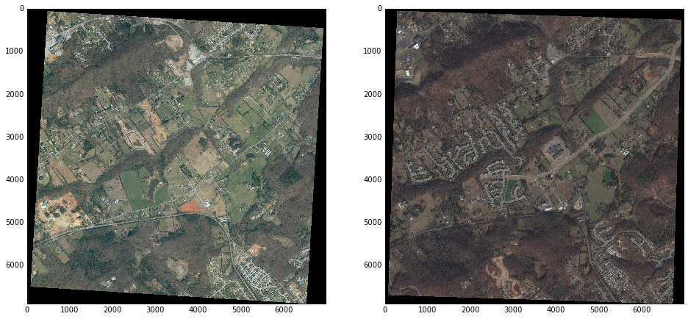

Figure 1

So before we start to use our detect method to these images, we need to do a pre-processing procedure for them. More specific, we should do some rotations to let one image matching the other, our method is to make the bases of both images parallel to the bottom line, crop the black margins, and pick the maximum mutual rectangle area for both images with the same resolution. (Figure 2) After this, we can get two processed satellite images which are ready to be used for next step.

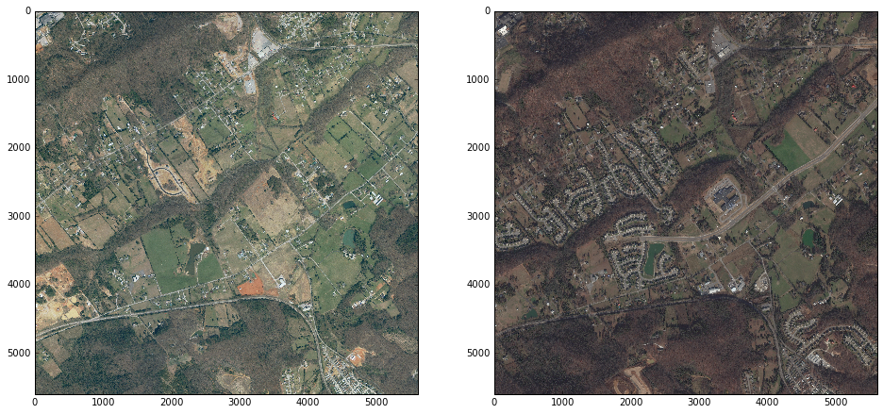

Figure 2

Before dividing these two images into grids, we noticed that there are many green color natural objects (trees, grasses, etc.) in both images. These massive amount of same color objects could affect the final detection result. To identify this kind of influence, we can transform the original images into different color’s channels. In each channel, we compare the difference between the objects respectively.

Images in red color channel:

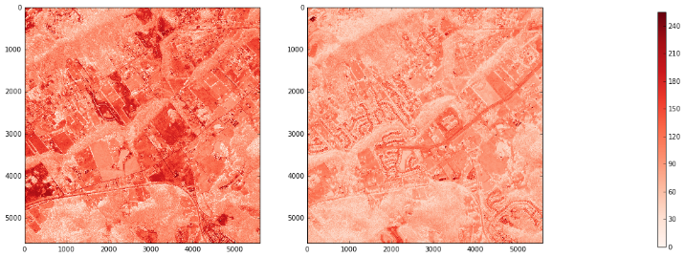

Images in green color channel:

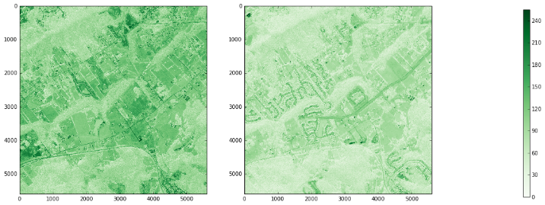

Images in blue color channel:

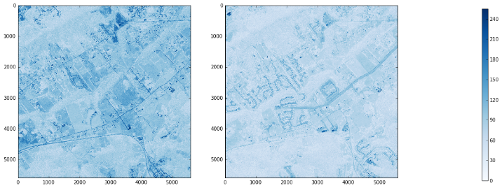

The next step is to divide the images into grids. For each image (with length l and width w), we divide image arrays into square grids based on preset grid size and scale RGB inside each grid. The example grids in original and RGB channels in older image as following:

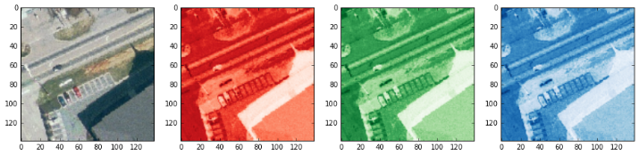

Relatively, the corresponding sample grids in these channels in newer images are:

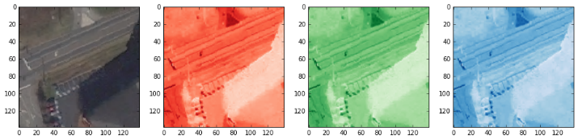

The distinct difference between these two sets of samples are the building shadows. These shadows can be handled by using additional dimension images to reduce the effects.

Below are the extra sample grids in original image and express in single color channel:

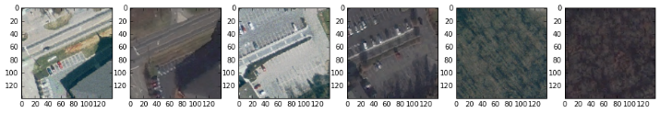

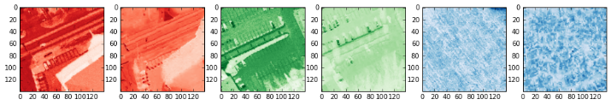

Now we can transform the images. After dividing images into the grids properly, we convert all of these grids into their relative Gaussian distributions. Besides the RGB parameters we already employed, to better distinguish these grids, we also add each pixel’s coordinates (row x and column y) as extra parameters. Then use this new matrix to compute the Kullback–Leibler (KL) divergence between two Gaussian distributions. As the result, we got a KL divergence map (Figure 3), which is critical to detect changes between the images.

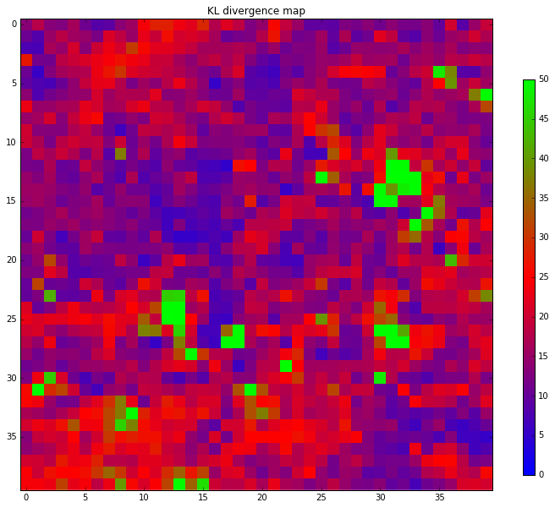

Figure 3

Using the KL divergence map, we can do a preliminary comparison overlaying this map on the original images (Figure 4):

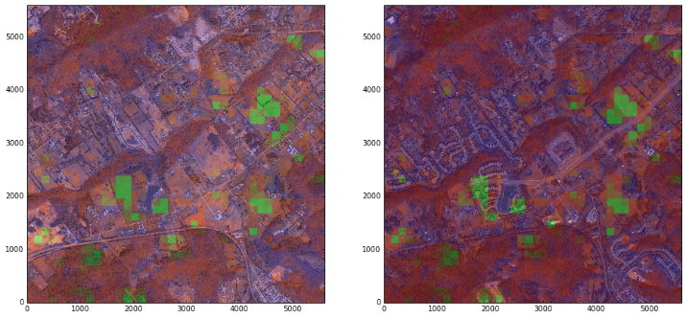

Figure 4

The green color square grids indicate some differences we detected by using our KL divergence map. However, the majority changing parts are still indistinctive. To solve this, we will adopt Gaussian Mixture Model to the map.

We build the GMM model-based clustering model by subset of KL divergence map, this GMM clustering model is able to categorize the changes on KL divergence map, then we can compare the difference between the two images by plotting the change map (Figure 5):

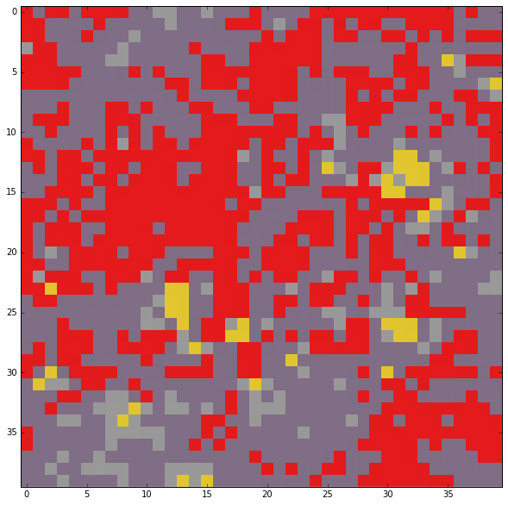

Figure 5

This is the final output from our method. As before, to compare the changes between two images more specific, we overlaid this GMM change cluster map onto the original satellite maps. (Figure 6) It will also be easier for us to evaluate the accuracy of our method.

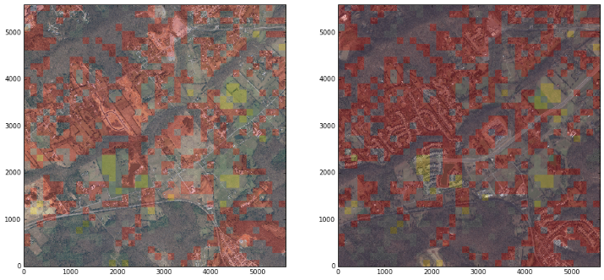

Figure 6

In the Figure 6, the red and green rectangle grids suggest the areas has relatively greater changes, all other parts are the areas that basically remain the same.

By observing these two original satellite images with human eyes, we could say that all major difference between two images are located in the red grids area. Particularly, those tree lines located at the central of images can be excluded perfectly from the changing parts. This is a very positive signal that suggests our method is useful for detecting the image changes. However, the final result map is not quite accurate to distinguish every detail of differences, and some minor changes are not detected by the change map. The potential reason of this may include the components k choosing, grids’ size selecting, number of parameters using or some specific algorithm implementation problem.

1. Conclusions and future directions

In our project, we presented a probabilistic change detection method. Although our method can detect the artificial changes between different satellite images to some extent, it still has quite parts to improve. Mostly the inaccuracy issue.

We attempted to use a method called Normalized Difference Vegetation Index (NDVI) when we tried to improve the accuracy. This is a unique technique to distinguish artificial buildings and vegetation with relative difference between R and G pixels. However, it did not perform well in our experiment (Figure 7), this is a potential direction in our future study.

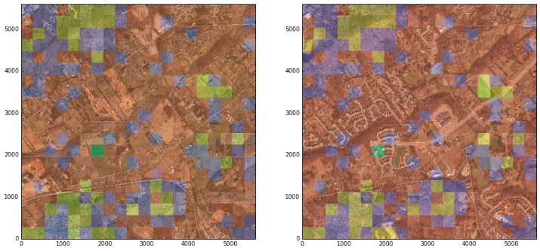

Figure 7

It’s a challenging task for us to keep improving the performance of our method, but we believe after enough times’ testing and adjusting, this method will have good prospects.

Acknowledgment

We would like to thank our professor Dr. Raju Vatsavai and all teaching assistants for various suggestions and feedbacks about software tools using and algorithm implementation to our project study.

References

1. Vatsavai, R. Graesser, J. 2012. “Probabilistic Change Detection Framework for Analyzing Settlement Dynamics Using Very High-resolution Satellite Imagery. ICCS: 907-916.
2. Goldberger, Jacob, Shiri Gordon, and Hayit Greenspan. "An efficient image similarity measure based on approximations of KL-divergence between two Gaussian mixtures." Computer Vision, 2003. Proceedings. Ninth IEEE International Conference on. IEEE, 2003.
3. Beecks, Christian, et al. "Modeling image similarity by gaussian mixture models and the signature quadratic form distance." 2011 International Conference on Computer Vision. IEEE, 2011.
4. Hershey, John R., and Peder A. Olsen. "Approximating the Kullback Leibler divergence between Gaussian mixture models." 2007 IEEE International Conference on Acoustics, Speech and Signal Processing-ICASSP'07. Vol. 4. IEEE, 2007.
5. Adams, J. B., Sabol, D. E., Kapos, V., Almeida-Filho, R., Roberts, D. A., Smith, M. O., et al. (1995). Classification of multiple images based on fractions of endmembers: Application to land-cover change in the Brazilian Amazon. Remote Sensing of Environment, 52, 137−154.
6. Fei Yuan, Marvin E. Bauer, Comparison of impervious surface area and normalized difference vegetation index as indicators of surface urban heat island effect..., Remote Sensing of Environment (2006), doi:10.1016/j.rse.2006.09.003